FASTENER DIMENSIONS AND SPECIFICATIONS: A Technical Guide

### Document Overview

This document serves as a comprehensive reference guide detailing the dimensional specifications, standards, and material properties for both **Metric** and **Inch-Series** hex head screws (bolts) and hex nuts.

It includes necessary technical data for engineers, designers, and tradespeople to ensure proper component matching and assembly, with a focus on dimensional tolerances and strength grading.

1. **METRIC Hex Head Screws (or Bolts) in mm**

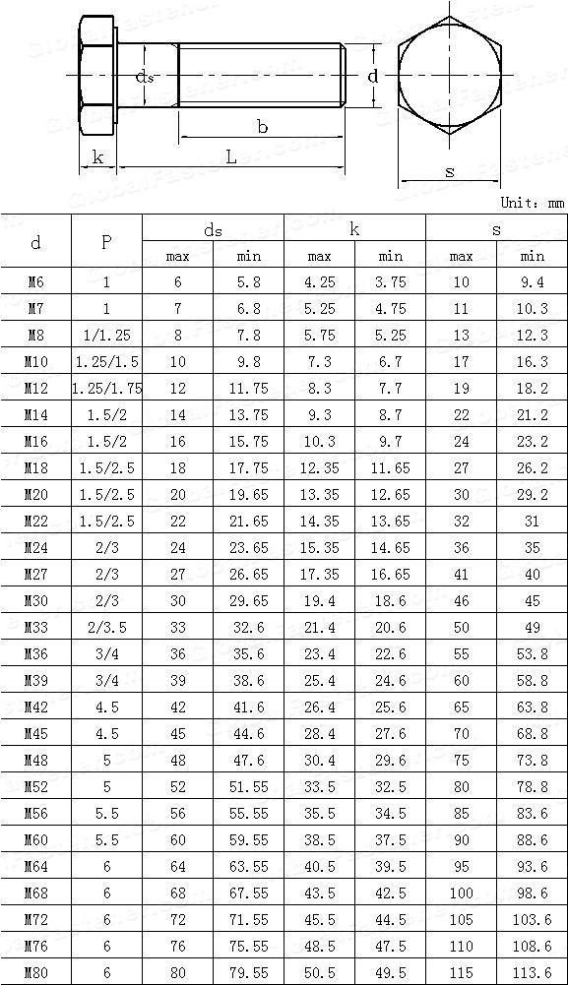

1. **Drawing and Dimensional Symbols**

The top drawing illustrates the screw's main features and uses letters to denote the dimensions provided in the table:

***d*** (Nominal Diameter): This is the basic size of the screw, which corresponds to the diameter of the shank and the thread. It is also the first column of the table (e.g., M10).

***P*** (Thread Pitch): The distance between two adjacent thread crests. This is an important parameter for matching the bolt to a nut.

***L*** (Nominal Length): The length of the shank, measured from the bearing surface under the head to the tip.

***b*** (Thread Length): The length of the threaded portion of the screw.

***k*** (Head Height): The distance from the bearing surface under the head to the top of the head.

***s*** (Width Across Flats): The distance measured across the parallel flats of the hexagonal head. This dimension determines the size of the wrench or socket required.

|  |  |  |
| --- | --- | --- |
| **Column Header** | **Description** | **Units** |
| d | Nominal Thread Diameter: The basic size designation (e.g., M10 means a metric thread with a 10 mm nominal diameter). | mm |
| P | Thread Pitch: The distance between threads. For some sizes (e.g., M10, M12), two pitches are listed (e.g., 1.25/1.5), indicating a choice between a coarse pitch (1.5 mm) and a fine pitch (1.25 mm). | mm |
| ds​ max / min | Shank Diameter: The maximum and minimum allowable diameter of the unthreaded portion (shank) of the screw. | mm |
| k max / min | Head Height: The maximum and minimum allowable height of the hexagonal head. | mm |
| s max / min | Width Across Flats: The maximum and minimum allowable dimension for the wrench size. | mm |

1. **Key Observations and Interpretation**

**Metric System:** The designation "M" (e.g., M10) and the "Unit: mm" confirm this is a table for **metric fasteners**.

**Tolerances:** The inclusion of "max" (maximum) and "min" (minimum) values for ds , k, s indicates that these are **dimensional tolerance limits.** This ensures that any screw manufactured to this standard will fit with a compatible nut and be usable with the specified wrench size.

**Pitch Selection**: For smaller diameters, a single pitch is often standard (coarse thread is assumed if not specified). For M10 and up, the table lists options for a **coarse thread** (e.g., 1.5 for M10) and a **fine thread** (e.g., 1.25 for M10). Coarse threads are the most common general-purpose choice.

Example (M10):

- It is an M10 screw with either a 1.25 mm or 1.5 mm pitch.

The shank diameter (ds) must be between 9.8 mm and 10 mm.

The head height (k) must be between 6.7 mm and 7.3 mm.

The required wrench size (s) is 17 mm, with the dimension across the flats between 16.3 mm and 17 mm.

**CONVERSION**

Inches to millimeter:

**1 inch = 25.4 millimeters**

1. **ASME/ANSI standards Hex Nuts (in inches)**

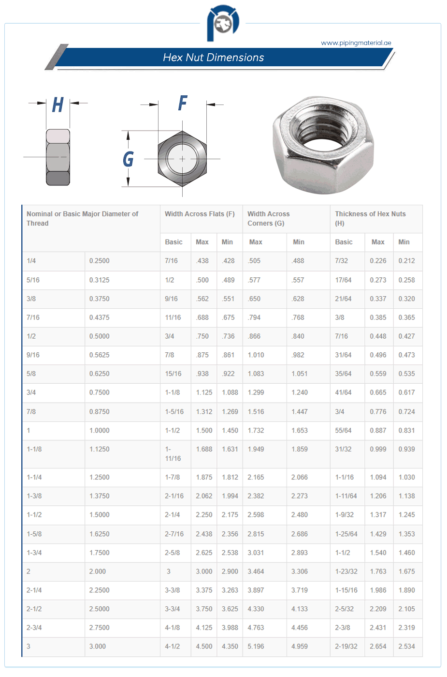

1. Dimensional Symbols

The illustration at the top shows a standard hex nut and uses the following letters to represent the dimensions in the table:

***F*** (Width Across Flats): The distance between the parallel sides of the hexagon. This is the wrench size.

***G*** (Width Across Corners): The largest distance across the hexagon, measured from one corner to the opposite corner.

***H*** (Thickness of Hex Nuts): The height or thickness of the nut.

The first column uses the nominal thread size, which is also the Nominal or Basic Major Diameter of Thread.

|  |  |  |
| --- | --- | --- |
| **Column Header** | **Description** | **Explanation** |
| Nominal or Basic Major Diameter of Thread | The standard size designation (e.g., 1/2 or 1.0000). | This is the basic diameter of the bolt the nut is designed to fit. |
| Basic | The nominal size for the bolt diameter in decimal inches (e.g., 0.5000). | For reference. |
| Width Across Flats (F) |  | This is the size of the wrench needed for the nut. |
| Basic | The nominal size of the wrench/socket required, expressed as a common fraction (e.g., 7/16). |  |
| Max | The maximum allowable dimension across the flats. | Ensures the nut can be placed by a tool and that the tool doesn't bind. |
| Min | The minimum allowable dimension across the flats. | Ensures the tool grips the nut properly without slipping. |
| Width Across Corners (G) |  | The largest physical dimension of the nut's face. |
| Max | The maximum allowable dimension across the corners. |  |
| Min | The minimum allowable dimension across the corners. |  |
| Thickness of Hex Nuts (H) |  | The height of the nut, which affects the thread engagement. |
| Basic | The nominal thickness of the nut, expressed as a common fraction (e.g., 7/32). |  |
| Max | The maximum allowable nut thickness. |  |
| Min | The minimum allowable nut thickness. |  |

### **Calculate Movement using Thread Pitch**

The movement is calculated by linking the angular rotation to the linear translation using the **thread pitch**.

The **thread pitch** is the distance between the crests of adjacent threads, which is also the distance the nut or bolt advances linearly for one full 360∘ rotation.

**Calculation:**

**Linear Distance per Revolution = Thread Pitch**

You need to know the pitch of your bolt's thread. For example, a common M10 × 1.5 thread has a pitch of 1.5 mm. This means for every 360∘ rotation, the nut or bolt moves 1.5 mm linearly.

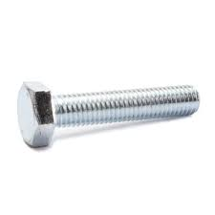**EXAMPLE: Calculate the Thread Pitch**  
I have a:

1. High strength grade 8 hex head screw

fully threaded

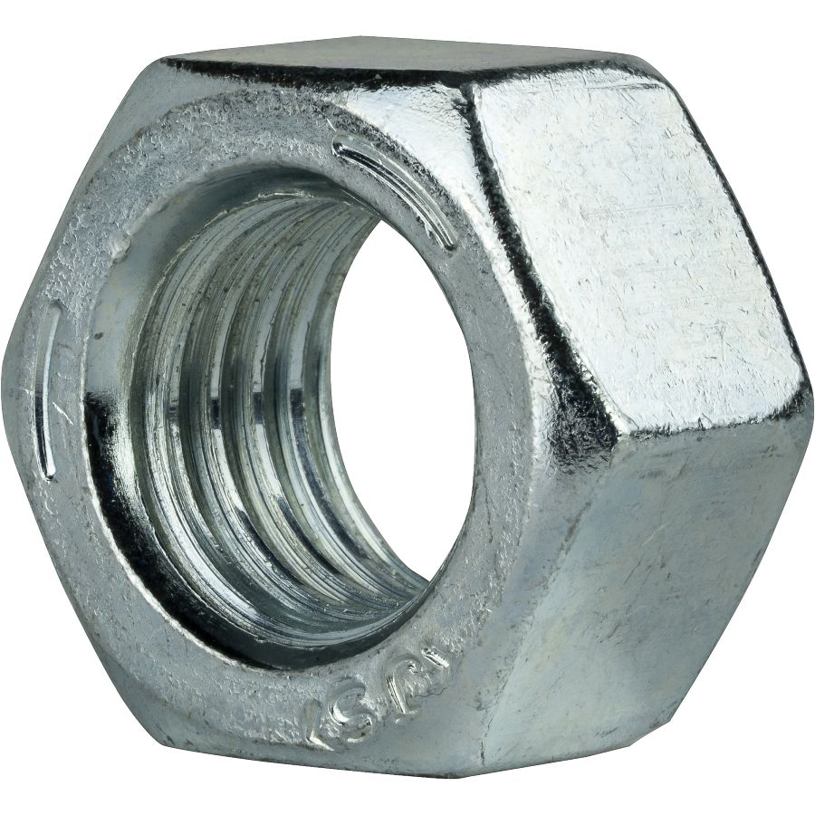lg. 2'', thread spacing coarse, head wd 7/16'', head ht 5/32'', tensile strength 150000psi, asme b18.2.1,sae j429

and a,

2. Medium Strength steel hex nut grade 5, zinc-plated,

1/4''-20 thread size, head wd 7/16'', head ht 5/32'' sae garade 5, asme b18.2.2  
  
Solution:

The movement is calculated by linking the rotation to the linear translation using the thread pitch.

The nut specification gives the thread size: 1/4"-20. This is a Unified Coarse (UNC) thread, meaning it has 20 threads per inch (TPI).

The thread pitch (P) is the linear distance the nut/bolt moves for one full revolution (360o):

P= 1

Threads Per Inch (TPI)

**P= 1 in = 0.05 inches**

**20​**

=> Therefore, for every 360o rotation, the nut will move 0.05 inches along the bolt.

|  |  |
| --- | --- |
| Specification | Explanation |
| High strength grade 8 | This is the highest strength grade for imperial (inch) steel fasteners defined by SAE J429. It is made from medium carbon alloy steel, heat-treated (quenched and tempered) for superior strength. Grade 8 bolts are marked with six radial lines on the head. |
| fully threaded | The threads run the entire length of the shank, right up to the underside of the head. |
| lg. 2'' | The nominal length of the screw, measured from under the head to the tip of the bolt. |
| thread spacing coarse | Refers to the Unified Coarse (UNC) thread series, which has fewer threads per inch than a fine thread (UNF). Coarse threads are generally easier to assemble, less prone to cross-threading, and better for brittle materials. |
| head wd 7/16'' | Head Width Across Flats (or wrench size). This is the distance measured across the parallel flats of the hexagonal head, which determines the size of the wrench or socket required. |
| head ht 5/32'' | Head Height. The overall vertical dimension of the hexagonal head. |
| tensile strength 150,000 psi | The minimum tensile strength (pulling force) the screw can withstand before fracturing. This high value confirms its Grade 8 classification (150,000 pounds per square inch). |
| ASME B18.2.1 | The dimensional standard established by the American Society of Mechanical Engineers (ASME). This specification governs the physical dimensions of the hex head screw, such as the head width, height, and body diameter. |
| SAE J429 | The material and mechanical properties standard established by the Society of Automotive Engineers (SAE). This is the specification that defines the high-strength properties and marking for Grade 8 fasteners. |